How to change Google sheets drop down list color

A dropdown list in Google Sheets, also known as a data validation dropdown, is a feature that allows you to create a list of predefined options from which users can select a value. It provides a convenient and user-friendly way to ensure that data entered into a cell is limited to the options available in the dropdown list. You can change color of options in this data validation drop down.

You are the financial manager of a company, and your responsibility is to review and approve or reject budgets submitted by various departments. You use Microsoft Excel to maintain a record of budget requests and track the approval or rejection status. Here is an example dataset illustrating this scenario:

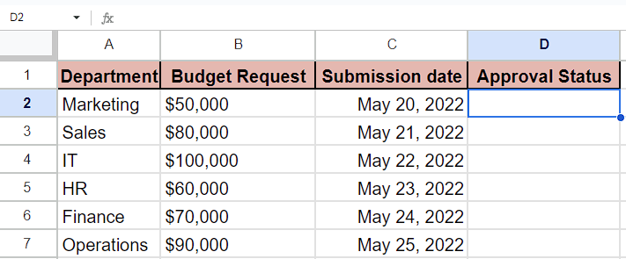

Follow the simple steps to insert and change the color of the drop-down list color:

## Step 1 – Selecting the cell

* Firstly, select an empty cell in which you want to add the drop-down list.
* We will teach you how to change the color of the drop-down list inserted in this cell later in this tutorial.



## Step 2 – Inserting the drop-down list

* After selecting the cell, locate the **Data tab** and click on it and **list of options** would appear on your screen.
* Then, click on the option named **Data Validation.**
* After clicking on the **"Data Validation" option**, a **data validation rules box** will open on the right side of your spreadsheet.
* You can also open this by **Insert Tab or context menu.**



## Step 3 - Setting rules for Drop-down list

* In the data validation rules box, click on **"Add a rule."**
* Then, **write the range of cells** in **Apply to Range option.** For example, it is **D2:D7** in our case.
* **Two boxes** will appear under the criteria, labeled as **Option 1 and Option 2.**
* You can **rename these options** according to your preference. For instance, we’re changing **Option 1 to "Approved"** and **Option 2 to "Disapproved."**
* If you want to **add more options,** click on **"Add another item"** below the drop-down list options.
* In our example, we added another option and named it **"Pending.**



## Step 4 – Changing the color of Drop-down list

* Once you’ve set up rules for drop-down list, locate the **grey circle adjacent** to the **options** which we have named.
* Click on this circle, and a **box** will appear with a **variety of** **color options** to choose from.
* **Choose any color you like** and this color would be **assigned to the option** that you’ve selected.
* Repeat the above step for changing color of **other options** **in** **drop-down list.**
* For instance, we’ve assigned **green color** to option named **“Approved”**, **red color** to option named **Disapproved** and **yellow color** to option named **“Pending”.**
* Then, click on the **any cell containing the drop-down list,** and click on it.
* Next, choose **an option from the dropdown menu**, and it would **acquire** the **color corresponding** to the **selected option.**

